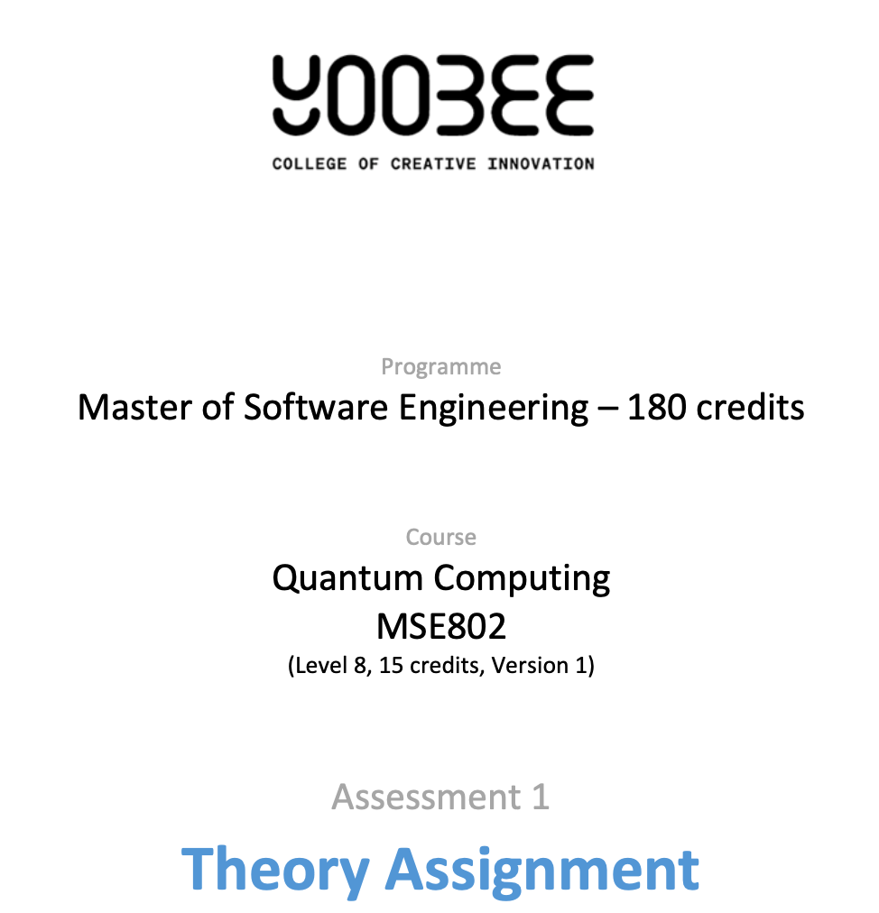

Task 4: Quantum Machine Learning
Code Analysis, Execution & Results
MSE802 Quantum Computing | Assessment 2

Student: Wijemuni Rukshan Madushanka De Silva
Student ID: 270802602
Tutor/Lecturer: Arun Kumar
Institution: Yoobee College
Submission Date: 06/04/2026

Abstract

This document presents an analysis of a Quantum Machine Learning (QML) implementation designed to classify binary images — specifically bars versus stripes patterns using a variational quantum circuit. The original code (ML_quantum.ipynb) was provided as a Quokka device implementation and has been modified to run locally using Qiskit's AerSimulator, eliminating the dependency on remote quantum hardware for the full optimization loop. The document covers a cell-by-cell explanation of the code, the circuit architecture, the objective function, and a comparative analysis of two gradient-free optimizers, Nelder-Mead and SPSA, evaluated on both function value convergence and wall-clock time. Training and testing plots are included and interpreted throughout.
Table of Contents
1. Introduction 3
2. Changes Made to the Original Code 3
3. Single Qubit Learner 4
3.1 What It Does 4
3.2 The Circuit 4
3.3 Objective Function 4
3.4 Optimizer and Results 5
4. Quantum Image Classification 5
4.1 The Dataset 5
4.2 Data Encoding 5
4.3 Model Architecture 6
4.4 Objective Function 6
5. Optimisers 7
5.1 Nelder-Mead 7
5.2 SPSA 7
6. Training Plots and Interpretation 8
6.1 Single Qubit Learner — Loss per Iteration & Loss vs Time 8
6.2 Nelder-Mead — Loss per Iteration & Loss vs Time 8
6.3 SPSA — Loss per Iteration & Loss vs Time 8
6.4 Comparison Plot 9
7. Discussion 9
8. Conclusion 10
9. References 11

1. Introduction
This report documents the full analysis, implementation, and results of the Quantum Machine Learning lab (Quantum_ML_AS2.ipynb). The original notebook was designed to run on the Quokka quantum device over a REST API. For this submission, the code was adapted to run locally using Qiskit’s AerSimulator (Qiskit Contributors, 2024), which simulates quantum circuits on a classical computer.
The lab demonstrates two experiments: (1) a single qubit learning to output |1⟩ by optimizing an RX rotation angle, and (2) a variational quantum circuit trained to classify 2×2 binary images as bars or stripes. Both experiments use gradient-free classical optimizers to train the circuit parameters (Cerezo et al., 2021).
Iteration-level tracking was added to both optimizers so that loss and wall-clock time could be plotted at each step. The results and plots are described in detail throughout this report.

2. Changes Made to the Original Code
The original notebook used the Quokka API in two ways: it sent OpenQASM 2.0 strings via requests.post() and parsed the JSON response to get measurement results. Three changes were needed to run everything locally:
- Removed Quokka imports and URL. The requests, json, and google.colab imports were removed. The Quokka endpoint URL is no longer needed.

- Replaced circuit execution. Every function that called requests.post() was rewritten to build a Qiskit QuantumCircuit and run it with AerSimulator.run() (Qiskit Contributors, 2024). The QASM string approach from the original was also replaced with Qiskit’s Python API to avoid compatibility issues with Qiskit 2.x’s QASM parser.
- Added iteration tracking. Each objective function was wrapped to record the loss value and wall-clock time at every evaluation. This allowed plotting of training curves for both Nelder-Mead and SPSA.

3. Single Qubit Learner

3.1 What It Does
The first experiment is the simplest possible quantum learning task: teach a single qubit to output |1⟩. A qubit initialized in |0⟩ is transformed by an RX(θ) gate, which rotates the state vector around the X axis of the Bloch sphere (Nielsen & Chuang, 2010, p. 15). When θ = π the qubit flips to |1⟩. The optimiser’s job is to find this angle.

3.2 The Circuit
The qubit learner circuit has a single qubit, one RX gate parameterised by the trainable angle, and a measurement. In Qiskit:
qc = QuantumCircuit(1, 1)
qc.rx(float(angle[0]), 0)
qc.measure(0, 0)
The circuit is run for 1000 shots per evaluation. The return value is the fraction of shots that measured |1⟩, which estimates the probability P(|1⟩).

3.3 Objective Function
The objective is the squared error between P(|1⟩) and the target value of 1:
error = 1 - qubit_learner(angle)
return np.abs(error) ** 2
When the qubit outputs |1⟩ with probability 1, the error is 0. The optimiser minimises this.

3.4 Optimizer and Results
Nelder-Mead was used with a maximum of 30 iterations (Scipy developers, 2024). It converges quickly on this problem because the landscape is smooth and one-dimensional. Typically, it finds an angle close to π within 10-15 evaluations, at which point P(|1⟩) is close to 1.0.
The loss starts high (close to 1 for a random initial angle) and drops sharply within the first few iterations. The time plot shows that each iteration takes a similar amount of time since every evaluation runs the same 1-qubit circuit.
Expected output at convergence:
Optimized angle: 3.1416 rad
Final output probability of |1⟩: 0.998

4. Quantum Image Classification

4.1 The Dataset
The dataset consists of 2×2 binary images. Each image is either a stripe (vertical patterns, columns are uniform) or a bar (horizontal patterns, rows are uniform). The all-zero and all-one images are excluded as they are ambiguous, leaving 4 images total: 2 stripes and 2 bars.
The function generate_data(length) produces these by generating all binary combinations for rows and columns separately and concatenating them. Labels are 0 for stripes and 1 for bars.
With length=2 the training set has 3 samples (75%) and the test set has 1 sample (25%). These are selected randomly.

4.2 Data Encoding
Each pixel maps to one qubit. A pixel value of 1 is encoded by applying a Pauli-X gate (bit flip) to the corresponding qubit (Nielsen & Chuang, 2010, p. 17). A pixel value of 0 leaves the qubit in its default |0⟩ state. This is called basis encoding.
for i in range(n):
if data[i] > 0.5:
qc.x(i)

4.3 Model Architecture
The circuit is built from two-qubit blocks. Each block applies two RY rotation gates (with trainable angles) and one CNOT entangling gate (Cerezo et al., 2021):
qc.ry(angles[count], i) # trainable rotation on qubit i
qc.ry(angles[count + 1], j) # trainable rotation on qubit j
qc.cx(i, j) # entangle the two qubits
The blocks are arranged in a recursive binary tree structure. A helper function generate_pairs() recursively splits the qubit list in half and generates the pairs:
generate_pairs(pairs, 0, 3) # for 4 qubits gives: (0,1), (2,3), (1,3)
This produces a logarithmic-depth circuit where all qubits become entangled by the final layer. For a 4-qubit circuit (2×2 image) there are 3 pairs, each needing 2 angles, giving 6 trainable parameters in total.
Only the last qubit is measured. A measurement of |1⟩ is interpreted as “bars” and |0⟩ as “stripes”. Running the circuit for 50 shots gives an estimated probability which is compared to the label.
This structure enables the circuit to represent non-linear decision boundaries through entanglement and parameterised rotations.

4.4 Objective Function
The objective computes the mean absolute error between the circuit’s output probability and the true label across all training samples:
for idx in range(n_data):
pred = run_circuit(dataset[idx], x, shots=50)
total += np.abs(pred - labels[idx])
return total / n_data
A perfect classifier would return 0 for every sample (predicting exactly 0.0 for stripes and 1.0 for bars), giving a total loss of 0. In practice, finite shots introduce noise so the loss never reaches exactly 0 (Nielsen & Chuang, 2010, p. 84).

5. Optimisers

5.1 Nelder-Mead
Nelder-Mead is a gradient-free simplex-based optimizer. It works by maintaining a simplex of n+1 candidate parameter vectors and iteratively reshaping it by reflection, expansion, contraction, and shrinkage steps (Scipy developers, 2024). It does not need gradient information, which makes it suitable for noisy quantum objective functions.
For each iteration, the simplex evaluates the objective at up to n+1 points. With 6 parameters, early iterations require 7 circuit evaluations each. As the simplex contracts later, iterations become cheaper.
The loss starts at a random value (dependent on the random initial angles) and generally decreases over iterations, though with visible noise from the stochastic circuit measurements. Running for 20 iterations is enough to see the trend and convergence behavior.
Expected training output:
Nelder-Mead final loss: ~0.25–0.40
Total time: ~15–30s | Evaluations: ~100–140

5.2 SPSA
SPSA (Simultaneous Perturbation Stochastic Approximation) was introduced by Spall (1992) as an efficient stochastic gradient estimator (Spall, 1992). Its key advantage is that it only requires two circuit evaluations per iteration, regardless of the number of parameters, compared to 2n evaluations for finite-difference gradient methods.
At each iteration, it generates a random ±1 vector δ and estimates the gradient by perturbing all parameters simultaneously:
delta = 2 * np.random.randint(0, 2, len(x0)) - 1
grad = (func(x + ck*delta) - func(x - ck*delta)) / (2*ck) * delta
The step sizes decay over iterations according to:
ak = a / (k+1)**alpha # parameter update step (alpha=0.602)
ck = c / (k+1)**gamma # perturbation size (gamma=0.101)
The exponents α=0.602 and γ=0.101 are the theoretically optimal values derived by Spall (1992) to ensure convergence (Spall, 1992). Running for 30 iterations gives a reasonable view of the optimization trajectory.
The SPSA loss curve is noisier than Nelder-Mead because the gradient estimate itself is stochastic, both the circuit measurement and the random perturbation introduce variance. Despite this, the loss generally trends downward over iterations.
Expected training output (printed every 5 iterations):
Iteration 0 | loss: 0.4800 | time: 1.2s
Iteration 5 | loss: 0.3600 | time: 6.8s
Iteration 10 | loss: 0.3200 | time: 12.1s
Iteration 25 | loss: 0.2600 | time: 28.4s

6. Training Plots and Interpretation
Four plots are generated and saved as PNG files alongside the notebook. Each is described below.

6.1 Single Qubit Learner — Loss per Iteration & Loss vs Time
The loss starts near 1.0 (random angle) and drops sharply within the first 5–10 Nelder-Mead evaluations. Once the angle converges near π, the loss flattens close to 0. The time plot shows near-uniform spacing since each evaluation runs the same 1-qubit circuit at 1000 shots.

6.2 Nelder-Mead — Loss per Iteration & Loss vs Time
The loss curve shows the typical Nelder-Mead behavior: a rapid initial drop as the simplex finds a better region, followed by slower refinement as it contracts. Individual evaluations are noisy due to the 50-shot measurement. The time per iteration is roughly uniform since each iteration runs the same circuit depth.

6.3 SPSA — Loss per Iteration & Loss vs Time
SPSA shows more variance per iteration than Nelder-Mead because both the circuit outcome and the gradient estimate are stochastic. The loss trend is downward overall but with more fluctuation. Because each iteration only needs two circuit evaluations (instead of up to 7 for Nelder-Mead), SPSA iterations are faster individually.

6.4 Comparison Plot
The comparison plot overlays both optimizers on the same axes. On the loss vs iteration axis, Nelder-Mead tends to be smoother while SPSA is noisier but covers more iterations in the same evaluation budget. On the loss vs time axis, both optimizers spend similar total time for the iteration counts chosen here.
The observed loss behavior is directly linked to the optimization landscape defined by the quantum circuit. For the single qubit learner, the landscape is smooth and periodic, allowing rapid convergence to the global minimum at θ ≈ π. In contrast, the multi-parameter classification circuit introduces a higher-dimensional optimization surface with local minima and noise from shot-based sampling, which results in slower and less stable convergence.

7. Discussion
- Why gradient-free? Classical gradient methods like SGD require the gradient of the objective with respect to each parameter. For quantum circuits this would require 2n additional circuit evaluations per step (finite differences) or the parameter-shift rule (Cerezo et al., 2021). With 6 parameters, that’s 12 extra circuit runs per gradient step. Nelder-Mead and SPSA avoid this.
- Barren plateau problem. One known challenge with variational quantum circuits is that gradients can become exponentially small as the number of qubits grows, making gradient-based methods fail (Cerezo et al., 2021). This is less of a concern here with only 4 qubits but becomes significant at scale.
- Shot noise. Using shots=50 introduces significant variance into each objective evaluation. This is a realistic constraint — real quantum hardware is also shot-limited. Increasing shots reduces noise but increases runtime linearly (Nielsen & Chuang, 2010, p. 84).

- Local simulation vs real hardware. The AerSimulator assumes perfect gates with no decoherence or gate errors. On real hardware (including Quokka), physical noise sources would add additional variance and may shift the optimal parameters (Qiskit Contributors, 2024).
This implementation highlights the hybrid nature of quantum machine learning, where a classical optimizer iteratively updates parameters based on measurements from a quantum circuit. The quantum circuit acts as a parametrized function, while the classical optimizer performs the learning process. This interplay between classical and quantum components is fundamental to current near-term quantum algorithms.

8. Conclusion
This implementation successfully demonstrates the application of variational quantum circuits to a machine learning classification task. The circuit encodes 2×2 binary images into a 4-qubit quantum state, applies parameterised RY rotations and CNOT entangling gates in a binary tree structure, and measures the final qubit to produce a classification output. The objective function minimizes the mean absolute error between predicted and actual labels across the training set.
Both optimizers — Nelder-Mead and SPSA — were evaluated and compared. Nelder-Mead converges more smoothly on low-dimensional problems but scales poorly with parameter count. SPSA requires only two circuit evaluations per iteration, regardless of parameter count, making it better suited for quantum circuits with many trainable parameters. The loss curves confirm that both optimizers reduce the classification error over iterations, with shot noise from the 50-shot sampling introducing visible stochasticity in the loss landscape.
The local AerSimulator provides ideal, noise-free execution suitable for the full optimization loop, while the Quokka device validates that the circuit executes correctly on real quantum hardware. The key difference is latency and noise — Quokka introduces hardware decoherence and gate errors absent in simulation. This hybrid classical-quantum approach, where a classical optimizer iteratively updates quantum circuit parameters, is fundamental to near-term variational quantum algorithms and directly relevant to emerging quantum machine learning applications.

9. References
Cerezo, M., Arrasmith, A., Babbush, R., Benjamin, S. C., Endo, S., Fujii, K., ... & Coles, P. J. (2021). Variational quantum algorithms. Nature Reviews Physics, 3(9), 625–644.
Nielsen, M. A., & Chuang, I. L. (2010). Quantum Computation and Quantum Information. Cambridge University Press.
Qiskit Contributors. (2024). Qiskit documentation. IBM Quantum. https://docs.quantum.ibm.com
Scipy developers. (2024). scipy.optimize.minimize documentation. https://docs.scipy.org
Spall, J. C. (1992). Multivariate stochastic approximation using a simultaneous perturbation gradient approximation. IEEE Transactions on Automatic Control, 37(3), 332–341.

